Resources: Book
The Book makes it easy to create multi-page resources with a book-like format that includes main chapters and one level of sub-chapters. Books can be printed entirely or by chapter.

Contents
- Add a Book
- Add a Chapter/Sub-Chapter
- Print Book/Chapter
- More information

Add a Book
- Go to the course home page.
- Click on the Turn editing on button at the top right of the page. 
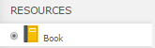
- Click Add an activity or resource.
- Click the radio button next to Book.
- Click on the Add button.
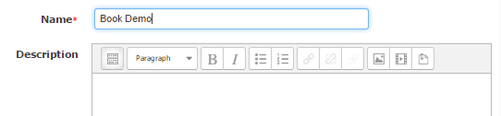
- Type a book Name. It is optional to have a book Description.

The Name will be the title given to the activity on the Moodle course page. For easy student navigation, choose a Name that is specific and clear as to what the resource is. The Description is for your reference unless you check the box below the Description: Display description on course page. Only choose this option if it is necessary. This clutters the home page of your course.
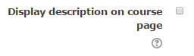
- Decide on how you would like the book chapters and subchapters to appear in the book menu. Appearance>Chapter Formatting
Indent | Bullets | Numbers | None
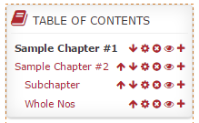 | 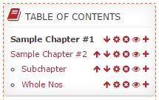 | 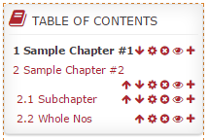 | 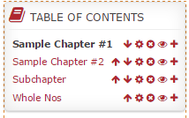
- Common Module Settings and Restrict Access settings may, in most cases, be ignored for books.
- Click on the Save and return to course or Save and display button.

Add a Chapter
- Add a Book (See Add a Book above).
- Click on the Book from the course home page or Save and display when you first create the book. Doing so will take you to an editing page where you can add a title and content.
- Type a Chapter title.
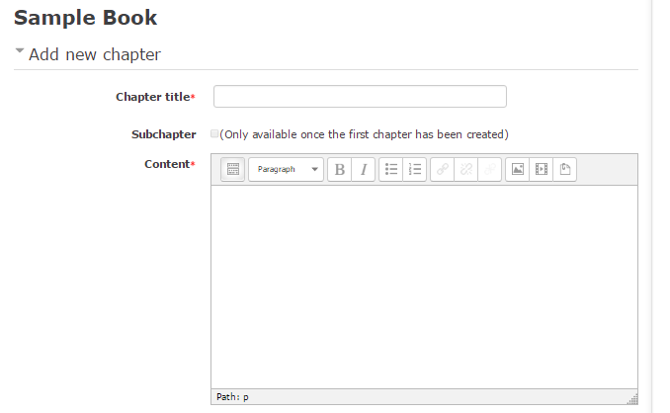
- Click on the Save changes button.
You can increase the size of the content screen by at the corner.
You can increase your editor options by selecting the Toolbar Toggle.
Vary your page content. Add videos, pictures, tables.

Add More Chapters and Sub-Chapters
1. Once you have created your first chapter, you will see it in the "Table of contents" block. You may add more chapters or sub-chapters. Select the + icon.
2. Check the Subchapter checkbox if necessary.
3. Enter your content.
4. Click on the Save changes button.
Other Editing Tools
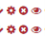


Move the Chapter or Sub-Chapter up or down using the arrows.
Use the gear to edit the content.
The X deletes the chapter/sub-chapter.
The open eye indicates where the students can see the chapter/sub-chapter. Click on the eye to close the eye and hide the content. It will become grey and you will still see the hidden book content.

Print Book/Chapter
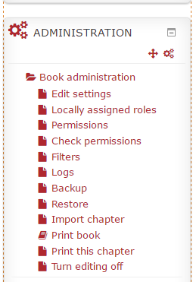
  - Click on the Print book or Print this chapter icon under the Administration block.

  - A new window will appear.
3. Click Print this chapter or Print this book at the top left of the window.
4. This will open the print dialog box or the print preview screen. Click on the OK button or the Print button.

More Information
- Books are not searchable.
- Books can have only 2 levels of navigation (chapters and sub-chapters).
- Use Filter settings under Administration to turn on and off glossary linking and multimedia plugins.

For more information, see Moodle Docs Creating a Book.

